Shriners Hospital Toy and Game Drive
The best way to bring our Jurisdiction back together after a year of being pulled apart is through a common cause. This year, I wanted that cause to be to collect toys and games for the patients of the Shriners Hospital for Children. The Shriners provide free healthcare to children in need of it. By donating items, we are helping to bring joy to the children who are staying in the hospital. The State Officers will be collecting items at all of the state events and chapters are highly encouraged to host toy drives in their communities. By working together, we can be a beacon of positivity for those who need it.
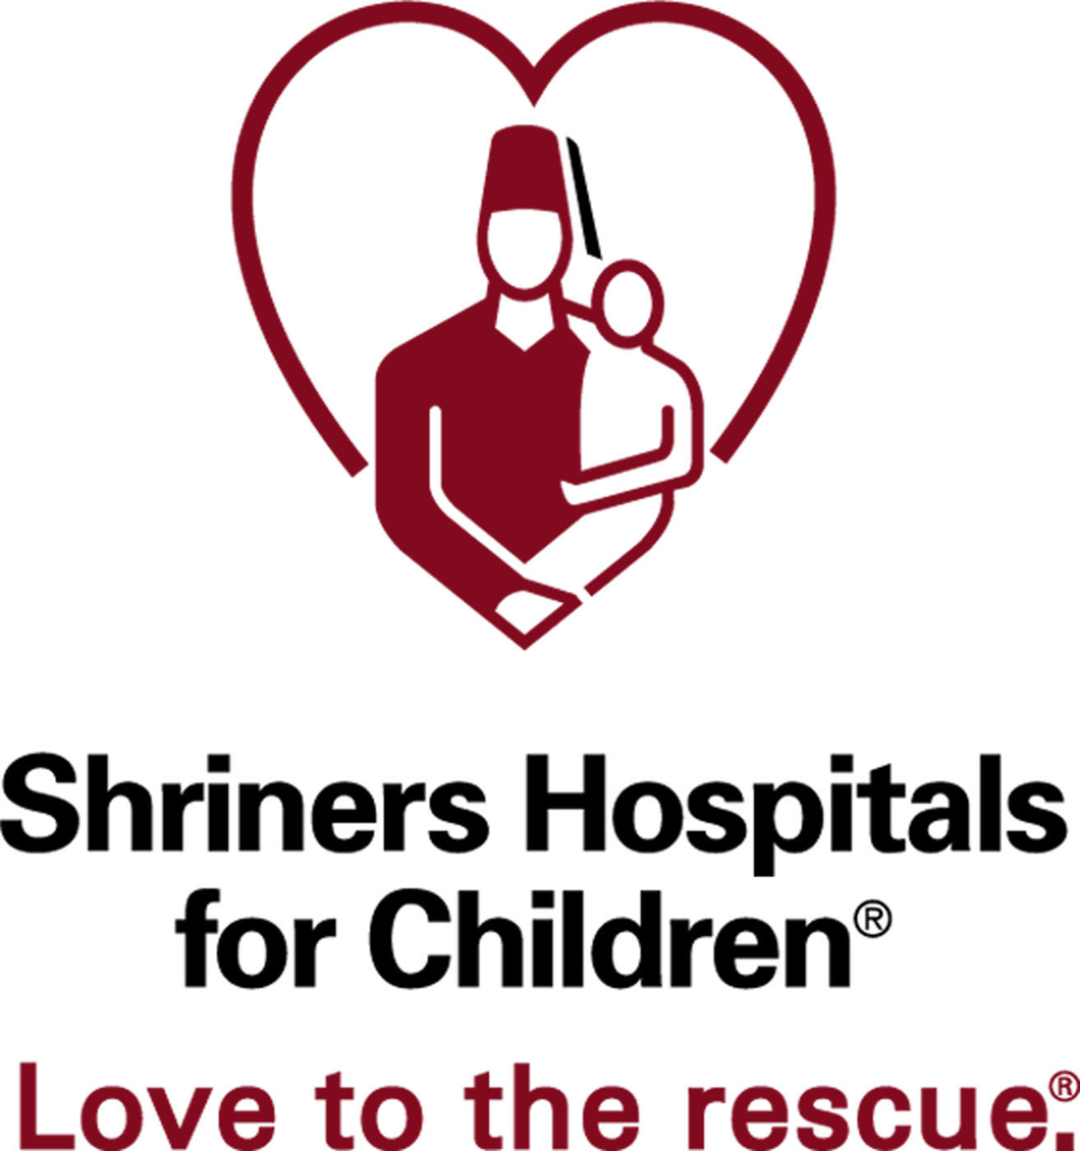
The following is a list of suggested items to donate to the Chicago Shriners Hospital:

Toys:
- New unwrapped toys and dolls
- Small toys such as yo-yos and dominoes
- Toys for children under age 2
- Small bottles of bubbles

Balls:
- Latex-free sports balls
- Nerf balls

Art supplies:
- Painting sets
- Coloring books – non violent
- Crayons, colored pencils and markers
- Velvet posters to color
- Stickers
- Play Dough/modeling clay
- Journals/diaries

Games:
- Playing cards
- Card games (UNO, Skip Bo, Old Maid)
- Board games

Other ideas:
- Backpacks
- Cameras (35mm, disposable, instant)
- DVDs (PG-13, PG and G ratings only)
- 2.5–5 lb. wrist weights
- Pedometers
The hospital gladly accepts donations of new, latex-free items. Unfortunately they cannot accept used toys, used car seats, used cloth diapers, decorative hanging quilts or any items that contain rubber or latex.

